Gamma Ray Spectroscopy and Beta Particles in a Magnetic Field
Elijah Gill
9 November 2023
Measuring the spectra of various radioactive sources and using the peaks to find the linear attenuation coefficient for lead and aluminium with the sources.
Finding the energy of beta particles emitted from a source using a magnetic field as a momentum selector.
1. Introduction
When radioactive isotopes of elements decay, the particles and waves they emit can be dangerous to people and, in high enough quantities, can pose a serious risk to our health.
However, radioactive decays can be useful processes that can help us perform tasks, such as geological mapping and uranium exploration [1], by detecting the gamma rays that are emitted during the decay chain of radioactive materials found in the ground.
Nuclear decays can help us understand the universe and its processes, for example studying beta decays led to the neutrino being theorised in 1933 and later discovered in 1956 [2].
Beta particles are also used in medicine; cancer therapy utilises beta particles to irradiate and kill tumours [3], magnetic fields could also be used to help guide the beta particles to the cancer, reducing the risk to nearby healthy cells [4].
The gamma ray spectroscopy experiment aims to confirm the energies and intensities of gamma rays radiated from several different sources, using a scintillation counter. Then to find the linear attenuation coefficient for aluminium and lead at multiple different energy levels.
The beta particles in a magnetic field experiment aims to see how beta plus and minus particles behave differently in a magnetic field and find the most common kinetic energy for beta particles released from the sources of sodium-22 and strontium-90.
2. Theory
Certain isotopes of elements are unstable, due to a surplus or deficit of neutrons in the nucleus, compared to the number of protons, these are known as radionuclides. When these isotopes decay they emit either alpha, beta plus, beta minus particles or gamma rays, to stabilise their nucleus. Gamma rays are different to the other forms of decay as they are high energy electromagnetic waves, also known as photons. They are emitted when a nucleus moves from an excited state to the ground state [5]. Due to energy states in nuclei being quantised [6], the energy of emitted gamma rays is limited to certain values, this is also the case for beta particles. By measuring a range of energies from nuclear decays, a spectrum can be produced to find the most common energies of particles and waves emitted.
Beta particles are electrons or positrons that have extremely high energies, emitted from the nucleus after a beta-minus or beta-plus decay respectively. The equations representing these decays are:
$β^{-} decay: n→e^{-}+p^{+}+ {\overline{ν}}_{e}$ $β^{+} decay: p^{+}→e^{+}+n+ ν_{e}$
These particles both have a charge, so their direction of movement can be changed using a magnetic field. For a charged particle moving perpendicular to the magnetic field, a force of magnitude qvB is experienced. This force is centripetal so causes the particle to undergo circular motion. This can be represented with the equation:
$qvB=\frac{mv^{2}}{r}$ (1)
where q = Charge [C], v = Velocity [ms⁻¹], B = Magnetic Field [T], m = Mass [kg], r = Radius of motion [m].
This can then be rearranged to find the momentum, p = qBr. And with the relativistic equation for energy,
$E^{2}=p^{2}c^{2}+m_{0}^{2}c^{4}$ (2)
where E = Energy [J], p = Momentum [Ns], c = Speed of light [ms⁻¹], $m_{0}$ = Mass [kg].
the kinetic energy, Q, of a charged particle travelling in a magnetic field perpendicular to its motion is given by:
$Q=\sqrt{{\left(qBrc\right)}^{2}+m_{0}^{2}c^{4}}-m_{0}c^{2}$ (3)
When a positron is emitted through beta-plus decay, it may interact with an electron from somewhere else in the source. The two particles will annihilate each other, causing two gamma rays, each with an energy of 511 keV, to be emitted in opposite directions [7].
The scintillation counter used for the gamma ray spectroscopy reads a range of energies, not just the energies of gamma rays from the radioactive sources. This is because of a combination of background radiation from the environment and Compton scattering, where the gamma rays collide with electrons and lose some of their energy before being absorbed and read by the counter. Leading to observable count rates between the expected peaks on the spectrum. The energy of a scattered photon is,
$E=\frac{E_{0}}{1+{(E}_{0}/m_{o}c^{2})(1-cosθ)}$ (4)
where E = Energy of scattered photon [J], E₀ = Energy of incident photon [J], m₀ = Mass [kg], c = Speed of light, θ = Scattering angle [rad]
the range of energies in which Compton scattering effects the spectra can be found by finding the maximum energy that can be transferred to a stationary electron that the gamma rays collide with. This happens when the angle of collision between the photon and electron is equal to pi (or 180 degrees), in this case the photon rebounds off the electron, transferring most of its energy. A small peak forms on the spectra at the energy of the scattered photons and a drop off point can be seen at the maximum energy the electrons can gain from scattering.
3. Method – Gamma Ray Spectroscopy
Part 1 – Calibration
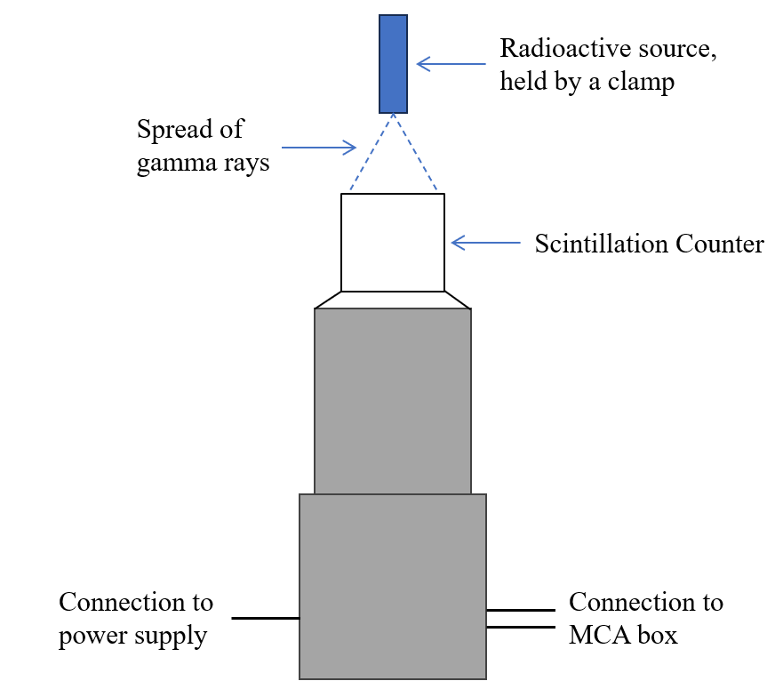
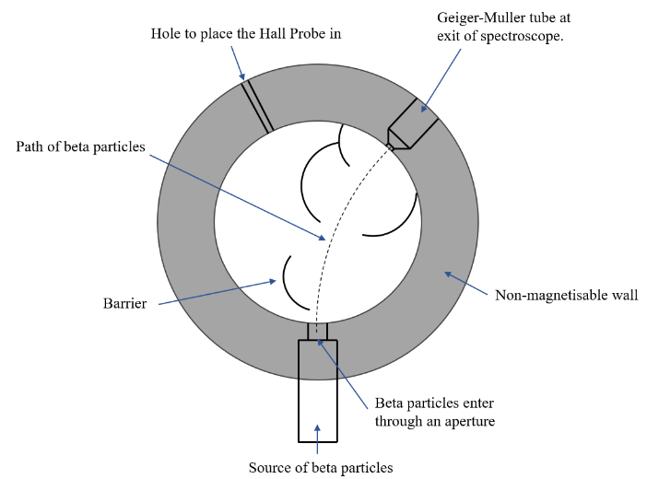
To set up the experiment, the scintillation counter was connected to both a power supply and an MCA box, which sends the data collected to a computer to be viewed and
Figure 1: (Left) Diagram of the equipment set up for the gamma spectroscopy experiment. (Right) Diagram of the beta spectroscope used in the beta particles in a magnetic field experiment.
analysed in CASSY Lab 2. A radioactive source would be pointed downwards from above the scintillation counter, held in place using a clamp stand, for the decays to be detected. Firstly, cobalt-60 (Co-60) was used to find a suitable voltage from the power supply so that all channels were covered by the spectra of data. Secondly, sodium-22 (Na-22) was used to calibrate the energy by assigning the true values of 511keV and 1275keV to the 2 peaks found in the sodium spectra. Once it was calibrated the running time for each measurement was set to 100 seconds, to allow for enough time for the peaks to be seen clearly.
Part 2 – Spectra of various sources
Three different radioactive sources, Co-60, Na-22 and a mixed nuclide preparation containing Americium-241 and Caesium-137, were measured. Each measurement was repeated twice for a total of 3 times per source. Using the CASSY Lab 2 software, gaussians of equal width could be fitted over the peaks seen in the spectra to find the energy at the peaks as well as its uncertainty. These energy values are averaged and then compared to known sources.
Part 3 – Attenuation of gamma rays
Slabs of aluminium and lead, with a thickness of 1mm or 5mm are used in combination to measure the spectra of Co-60 and the mixed preparation with varying thicknesses of material between the source and counter, held up using a Perspex cylinder placed around the scintillation counter. How much material that is used depends on the point where the material absorbs all the gamma rays. Once the data has been collected, and repeated, the linear attenuation coefficient was found using the equation,
$I=I_{0}\exp\left(-μx\right)$ (5)
where I = Intensity (Count-rate), $I_{0}$ = Initial Intensity (Count-rate with no material), $μ$ = linear attenuation coefficient [m⁻¹], x = Material Thickness [m].
This was done by rearranging the equation to,
$\ln\left(\frac{I}{I_{0}}\right)=-μx$ (6)
and plotting the data on a graph of ln(I / I₀) against x. The linear attenuation coefficient is the gradient of the graph produced. The half-value depths of the materials at a certain energy can be found with the plotted data, setting y = ln(0.5) and finding the corresponding thickness of material (x).
Part 4 – Further Investigation of the Mixed Preparation
Using eqn(4), the minimum energy a photon could have after being scattered was found, taking the incident energy to be the energy at the Cs-137 peak on the mixed nuclide preparation spectra. This was used to find the energy the electron would gain from being scattered with, E₀ – E. These energies were then related to features of the spectra created by the mixed nuclide source.
3. Method – Beta Particles in a Magnetic Field
Before using the radioactive sources, the magnetic field was tested to see what effect the current in the circuit had on the electromagnet’s output. The electromagnet was connected to a power supply and multimeter, in series. A range of -2A to 2A with an increment of 0.1A was tested and the magnetic field was measured for these currents using a Hall probe, connected to a gauss meter, that was placed in a hole in the non-magnetisable wall, as seen in figure 1. The magnetic field was plotted against the current and a line of best fit was fitted to the data, this was used later in the experiment to convert currents into magnetic fields.
For the experiment, sodium-22 (Na-22) and strontium-90 (Sr-90) were tested. The sources were placed in the hole with the aperture and a Geiger-Muller counter was held in the hole at the exit of the spectroscope using a clamp stand. Between a range of -2A and 2A, with an increment of 0.5A, the count was recorded over the course of 100 seconds, 3 times for each measurement. This was done for both Na-22 and Sr-90 separately.
The currents were then converted to magnetic fields using the relation found earlier in the experiment. Then the magnetic fields were converted into kinetic energies using eqn(3). The energy spectra of the beta particles were plotted to find the energy corresponding to the highest count rate to find the average energy of the beta particles released from the decays.

4. Results
Each radioactive source that was tested was found to emit gamma rays with 2 distinct energies.
Table 1: The energy corresponding to each count peak found from the spectra of 3 different radioactive sources.
Source | Peak 1 at Energy [keV] | Peak 2 at Energy [keV]
Cobalt-60 (Co-60) | 1184.7 ± 45.6 | 1343.1 ± 47.6
Sodium-22 (Na-22) | 507.7 ± 32.1 | 1285.5 ± 51.7
Mixed Nuclide Preparation | 24.1 ± 7.2 | 667.5 ± 35.1

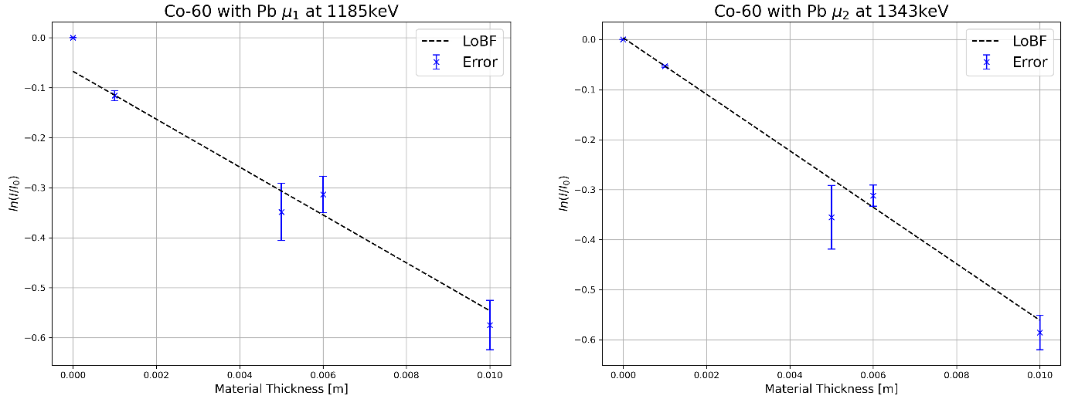
With the energies of each gamma ray for every source found, the linear attenuation coefficients were able to be derived. Plotting ln(I / I₀) against x for each combination of radioactive source and material produced,
Figure 2: (Left) Is the plotted data for the peak found at 1185 keV and (Right) shows the plotted data for the peak found at 1343 keV. Both are data collected from the spectra of Co-60 and lead, with a line of best fit plotted onto their respective data.
The linear attenuation coefficient (µ) for Co-60 and lead was found to be,
0.479 ± 0.045 cm⁻¹ at 1185 keV
0.565 ± 0.028 cm⁻¹ at 1343 keV
The half width for Co-60 and lead was found to be,
4.96 ± 23.6 cm at 1185 keV
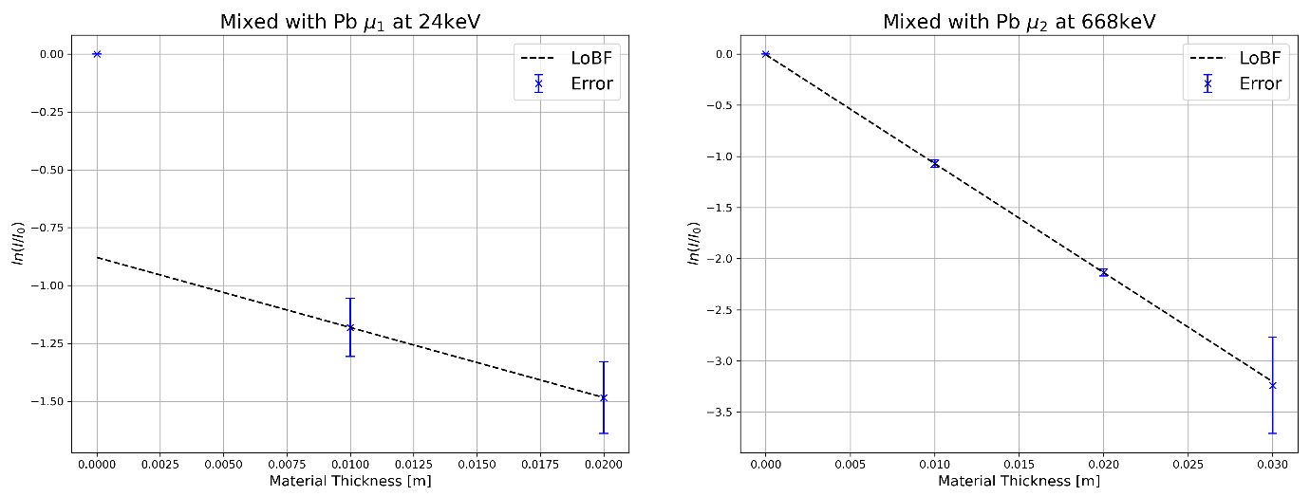
1.23 ± 36.2 cm at 1343 keV
Figure 3: (Left) Is the plotted data for the peak found at 24 keV and (Right) shows the plotted data for the peak found at 668 keV. Both are data collected from the spectra of the mixed source and lead, with a line of best fit plotted onto their respective data.
The linear attenuation coefficient for the mixed nuclide preparation and lead was found to be,
0.303 ± 0.200 cm⁻¹ at 24 keV
1.065 ± 0.050 cm⁻¹ at 668 keV
The half width for the mixed nuclide preparation and lead was found to be,
-0.61 ± 2030 cm at 24 keV
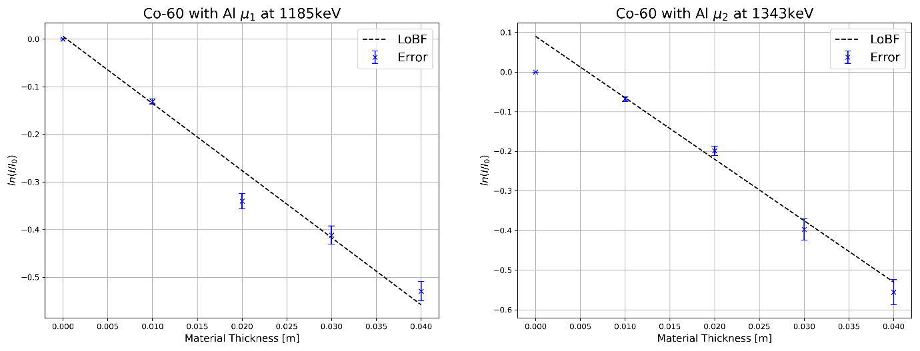
0.64 ± 510 cm at 668 keV
Figure 4: (Left) Is the plotted data for the peak found at 1185 keV and (Right) shows the plotted data for the peak found at 1343 keV. Both are data collected from the spectra of Co-60 and aluminium, with a line of best fit plotted onto their respective data.
The linear attenuation coefficient for Co-60 and aluminium was found to be,
0.141 ± 0.006 cm⁻¹ at 1185 keV
0.155 ± 0.008 cm⁻¹ at 1343 keV
The half width for Co-60 and aluminium was found to be,
4.96 ± 58.4 cm at 1185 keV
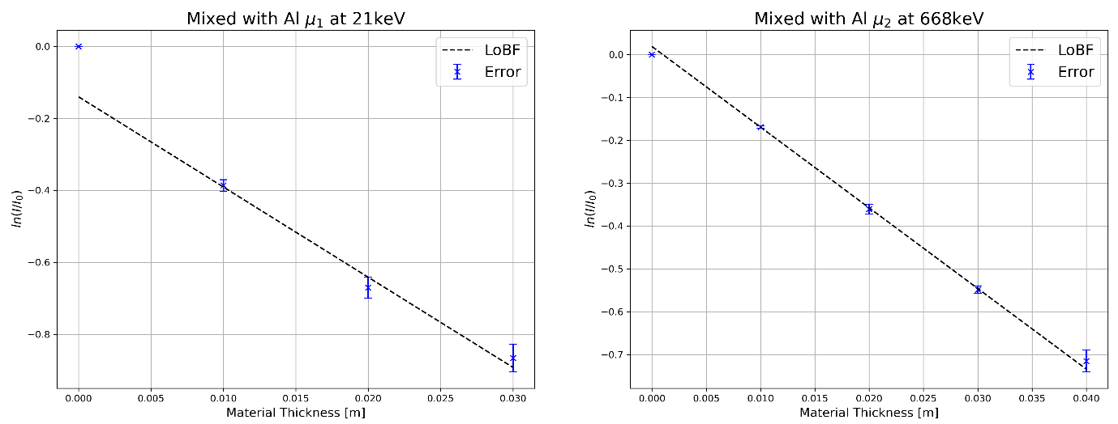
5.05 ± 77.2 cm at 1343 keV
Figure 5: (Left) Is the plotted data for the peak found at 24 keV and (Right) shows the plotted data for the peak found at 668 keV. Both are data collected from the spectra of the mixed source and aluminium, with a line of best fit plotted onto their respective data.
The linear attenuation coefficient for the mixed nuclide preparation and aluminium was found to be,
0.251 ± 0.019 cm⁻¹ at 24 keV
0.188 ± 0.004 cm⁻¹ at 668 keV
The half width for Co-60 and lead was found to be,
2.21 ± 194 cm at 24 keV
3.78 ± 40.8 cm at 668 keV
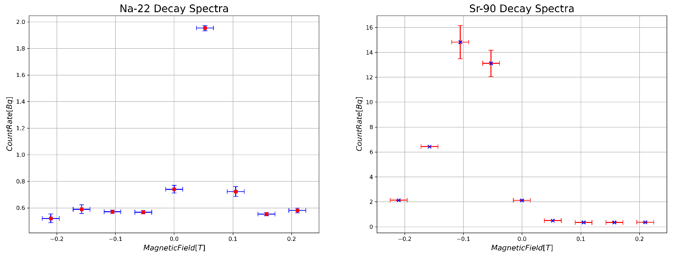
The results of beta particles in a magnetic field,
Figure 6: (Left) Shows the spectra for the Na-22 decay, (Right) is the spectra for the Sr-90 decay. Both plotted with magnetic field on the x-axis to easily see the peaks generated by the data.
The most common kinetic energies for beta particles emitted were,
425.16 ± 5.79e-17 keV for Na-22
1.15 ± 6.58e-20 MeV for Sr-90
5. Discussion
The accepted energies for the peaks of the cobalt-60 spectra are 1173.2 and 1332.5 keV [8], the peak of the sodium-22 spectra is 1275 keV [9]. These values are like the results of the experiment and fall within the error bars of the observed values. Sodium-22 was recorded to have another peak at 507.7 keV, however this is due to an annihilation reaction between electrons and positrons which release 2 gamma rays with an energy of 511 keV each [7]. The mixed nuclide preparation contains caesium-137 and americium-241, these isotopes release gamma rays with energies of 662 keV [10] and 59.6 keV [11] respectively. The caesium-137 gamma emission was detected in the experiment and is close to, and within the error bars, of the observed result. However, the gamma ray emitted from the americium-241 source is not correct. This might be due to another gamma peak for americium at 26.3 keV, which may have been read instead of the larger value or skewed the data towards the smaller peak.
The linear attenuation coefficients were all close to the values stated in the gamma spectroscopy pdf and follow the trend of decreasing as the energy of the incident gamma rays increase, the values calculated could be more accurate by repeating the experiment with more thicknesses as some of the scenarios, such as the mixed nuclide with lead, didn’t have enough data to get a realistic value from.
The half-value depth values follow the gradient, set by the linear attenuation coefficient, so due to the gradient only being calculated from a small range of data points, there is a very big uncertainty that gets passed onto the error on the half-value depths. This leads to the half-value depths calculated having virtually no confidence in their validity.
The accepted values for the kinetic energies of sodium-22 and strontium-90 are 546 keV and either 1.173 or 1.333 MeV respectively. These values are close to the calculated values, but their uncertainties have most likely been calculated wrong. These values could be more accurate with more counts being taken at different currents, this creates clearer peaks in the spectra and gives a wider range of potential energies the beta particles could have. The lack of data point may have impacted this experiment as the 2 spectra expected from the Sr-90 source can not be distinguished from one another with the current data.
Compton scattering is responsible for the remaining peaks found on the spectra, apart from background radiation. Taking the maximum energy of a gamma photon to be 667.5 keV (the value observed from the Cs-137 decay chain) after Compton scattering, the minimum energy the photon can have is 184.8 keV, calculated using eqn(4). And the maximum energy an electron can have is 482.7 keV. On the mixed nuclide spectrum, there is a small peak at 165.2 keV, this is photons that have been scattered and lost the maximum amount of energy they can. At an energy of 448.8 keV, a sharp drop off occurs. This is related to the maximum energy of the electrons from Compton scattering. The values between these points are due to Compton scattering happening at different angles and multiple times before detection.
6. Conclusion
The gamma spectroscopy experiment produced observations that were similar to external sources, with discrepancies potentially due to a small size of data collected. The linear attenuation coefficients were also similar to the expected values, however the half-value depths calculated have little confidence due to the high uncertainties associated with them.
The beta particles in a magnetic field experiment produced values that are close to the expected ones from external sources, however due to the small data size, the peaks of the spectra produced could not be easily distinguished, potentially negatively affecting the values found from it.
7. References
[1] Fares Howari, Abdelaty Salman, Philip Goodell. Exploration of uranium with case studies [Internet]. 2022 [cited 2023 Oct 11]. Available from: https://www.sciencedirect.com/science/article/abs/pii/B9780323909921000038
[2] Hitoshi Murayama. The origin of neutrino mass. [Internet]. 2002 [cited 2023 Nov 8]. Available from: http://sandman.berkeley.edu/neutrino/PhysicsWorld.pdf
[3] Holland-Frei Cancer Medicine 6th edition. Radioimmunotherapy of Cancer. [Internet]. 2003 [cited 2023 Nov 8]. Available from: https://www.ncbi.nlm.nih.gov/books/NBK13926/#:~:text=Beta%20emission%20from%20radioisotopes%20kills,can%20also%20impact%20on%20myelotoxicity.
[4] Berrin Çavuşoğlu, Selda Sucu, Hatice Durak, Kadir Akgüngör, Hakan Epik, Türkan Ertay. Experimental and Simulation Analysis of Radiation of the Beta Emitting Sources in a Magnetic Field [Internet]. 2017 [cited 2023 Oct 11]. Available from: https://www.ncbi.nlm.nih.gov/pmc/articles/PMC5472087/
[5] Australian Radiation Protection and Nuclear Safety Agency. Gamma Radiation [Internet]. [cited 2023 Oct 11]. Available from: https://www.arpansa.gov.au/understanding-radiation/what-is-radiation/ionising-radiation/gamma-radiation
[6] Lawrence Berkeley National Laboratory. A guide to nuclear science [Internet]. 2018 [cited 2023 Oct 11]. Available from: https://www2.lbl.gov/abc/wallchart/teachersguide/pdf/Chap06.pdf
[7] Wikipedia. Electron-Positron Annihilation. [Internet]. 2023 [cited 2023 Nov 8]. Available from: https://en.wikipedia.org/wiki/Electron%E2%80%93positron_annihilation
[8] Nuclear Power. Cobalt-60 spectrum. [Internet]. 2023 [cited 2023 Nov 8]. Available from: https://www.nuclear-power.com/nuclear-engineering/radiation-detection/gamma-spectroscopy/cobalt-60-spectrum/
[9] Absolute ²²Na Radioactivity measurement by gamma efficiency variation of 4πβ-γ coincidence method. Yoshio Hino, Yasusi Kawada. [Internet]. [cited 2023 Nov 8]. Available from: https://inis.iaea.org/collection/NCLCollectionStore/_Public/27/014/27014358.pdf
[10] Gamma Spectacular. Cs 137 Gamma Spectrum. [Internet]. [cited 2023 Nov 8]. Available from: https://www.gammaspectacular.com/blue/cs137-spectrum
[11] Gamma Spectacular. Am241 Gamma Spectrum. [Internet]. [cited 2023 Nov 8]. Available from: https://www.gammaspectacular.com/blue/am241-spectrum

